Table of Contents

Introduction 2

Application Registration on Azure 2

Step 1 : App Registration >> Create New Application 2

Step 2> Keep a note of Client ID, Tenant ID along with Endpoints required for this POC 2

Step 3> Providing Access to the Application for Azure Vault Service 3

Step 4> Create a secret for the Application. 4

Step 5> Click a Resource Group >> create Key Vault 6

Step 6> Copy the vault Name and Vault URL 7

Step 7> Provide access to the Application to the key Vault 7

Step 8 >> Create a secret in Key Vault 9

POSTMAN testing of Key Vault API 11

Step 1> Setup environment variables (Better approach) 11

Step 2> Select the environment >> Configure Postman GET operation to hit Vault 12

Step 3> Hit Azure Vault – With No Token 13

Step 4> Retrieval of Token 13

### Introduction

Below are simple ways by which a Key Vault and all pre-requisites could be retrieved in order to use Azure Key Vault REST APIs to retrieve Secrets.

### Application Registration on Azure

***\*\*\*\* Please note that the app client id and secret will no longer work as its already been deleted \*\*\****

#### Step 1 : App Registration >> Create New Application

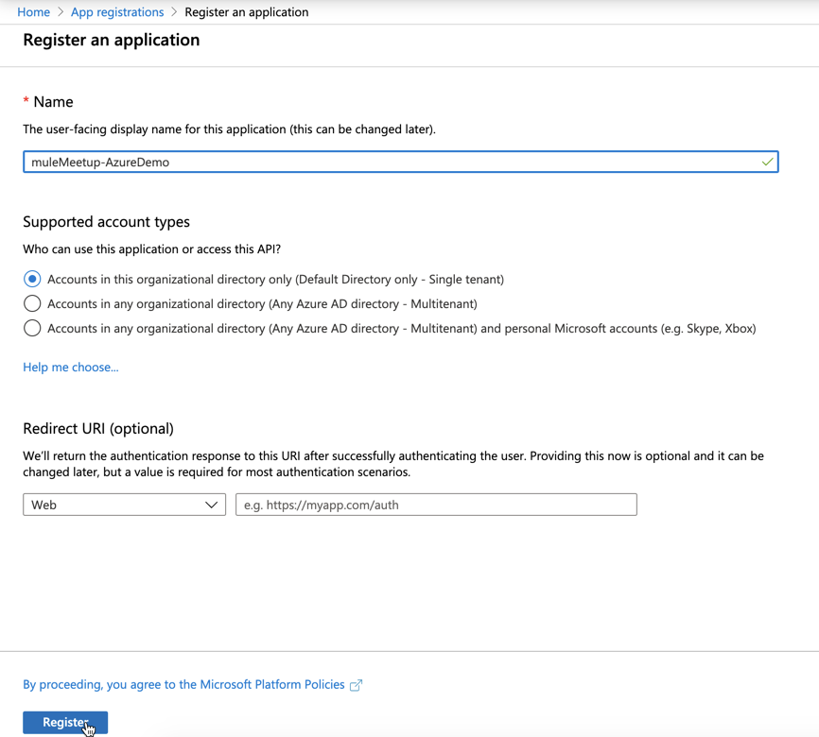

#### Step 2> Keep a note of Client ID, Tenant ID along with Endpoints required for this POC

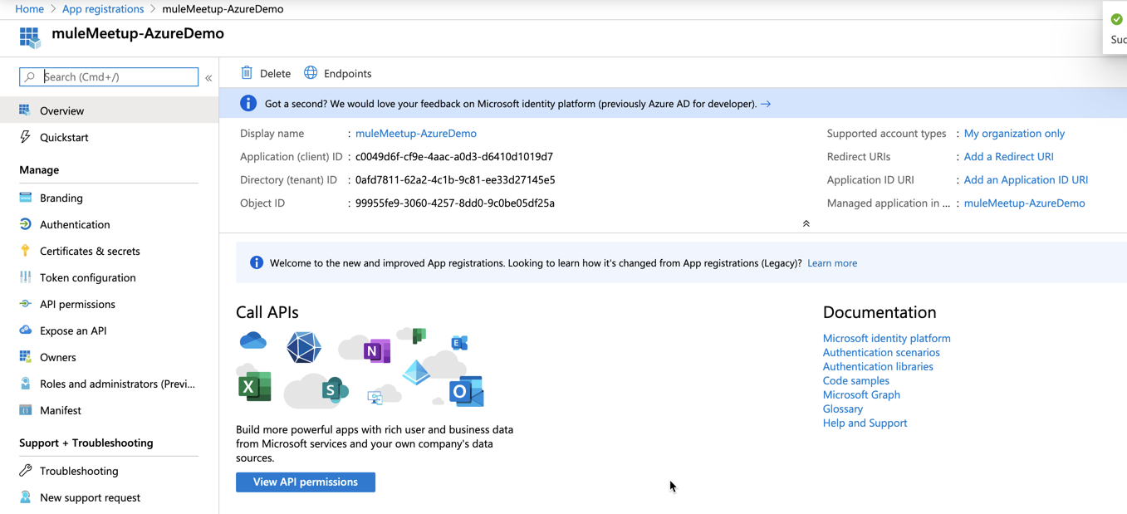

In this case:

Client ID, Tenant ID, Endpoint URL to authenticate against Azure Cloud for the org.

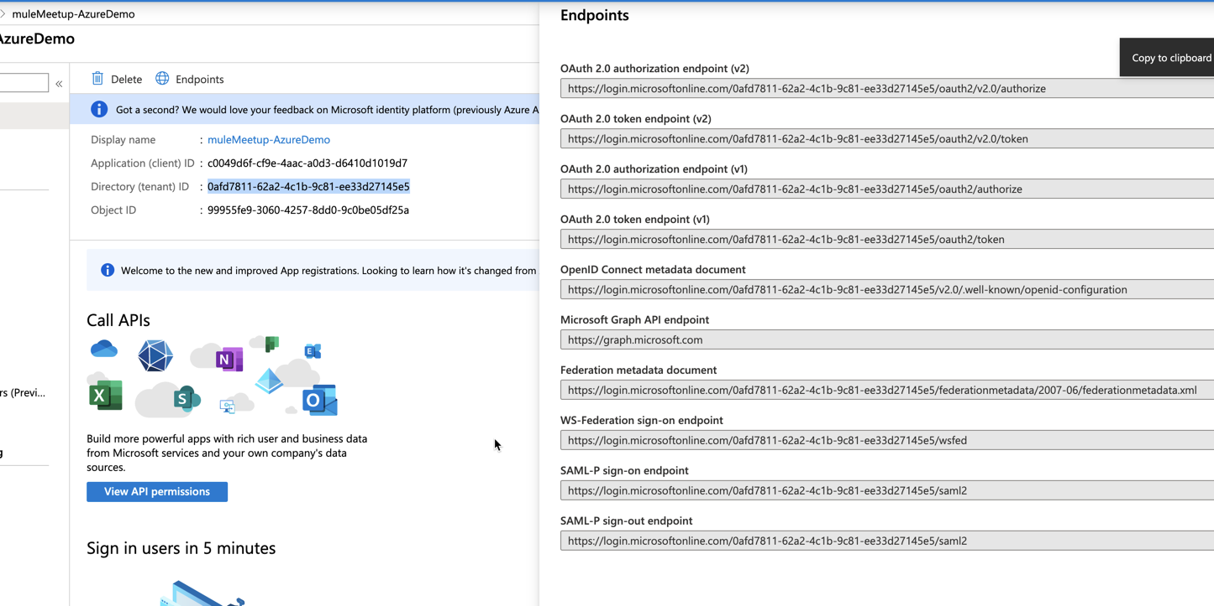

*Note: Endpoint Which we would use :* [*https://login.microsoftonline.com/0afd7811-62a2-4c1b-9c81-ee33d27145e5/oauth2/token*](https://login.microsoftonline.com/0afd7811-62a2-4c1b-9c81-ee33d27145e5/oauth2/token)

#### Step 3> Providing Access to the Application for Azure Vault Service

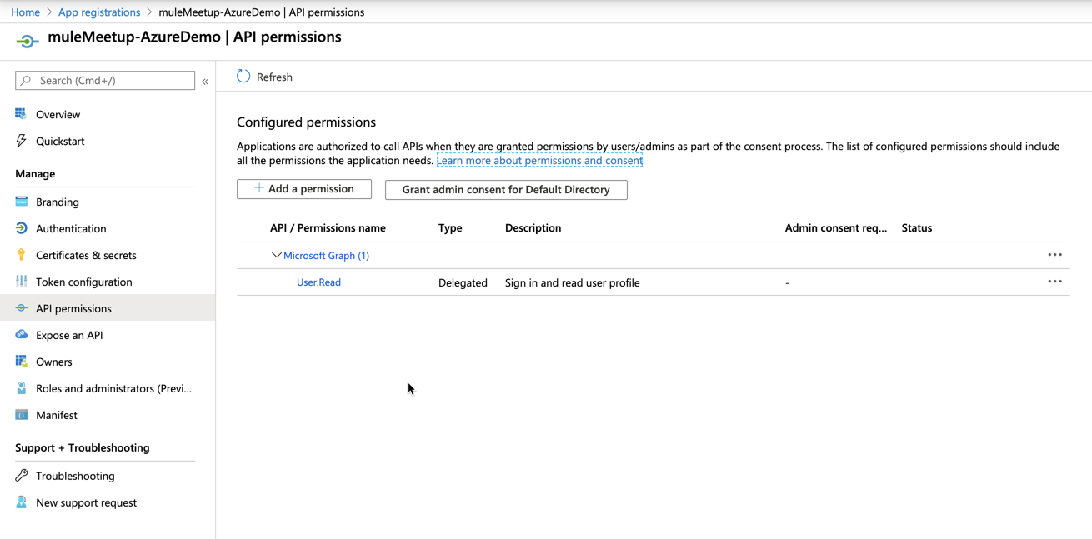

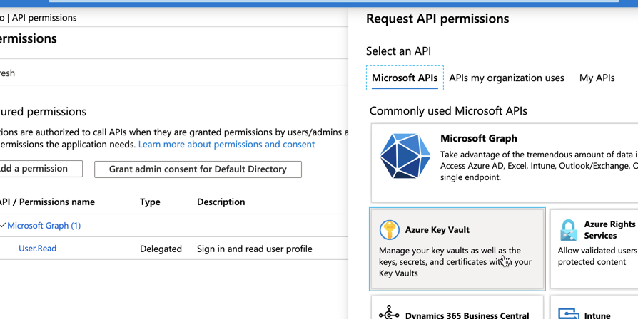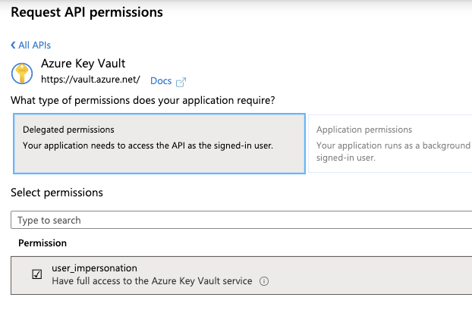

#### Step 4> Create a secret for the Application.

This is the client Secret to be used for the application.

Certificates & Secrets

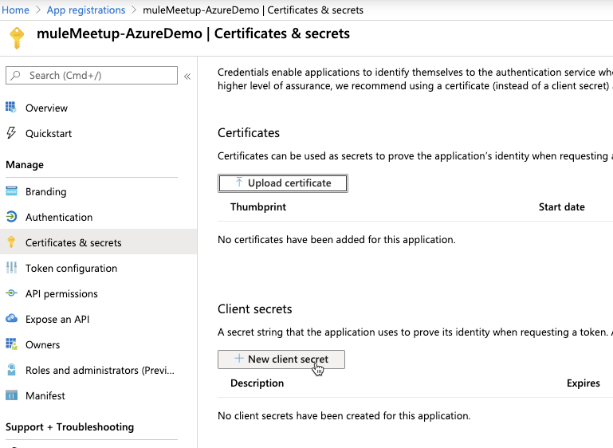

Provide a description and Expiry to the Client Secret.

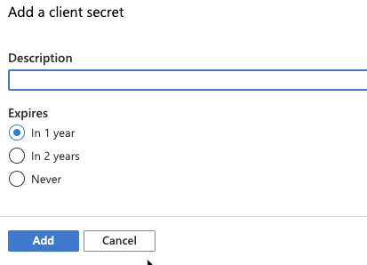

Copy the client secret

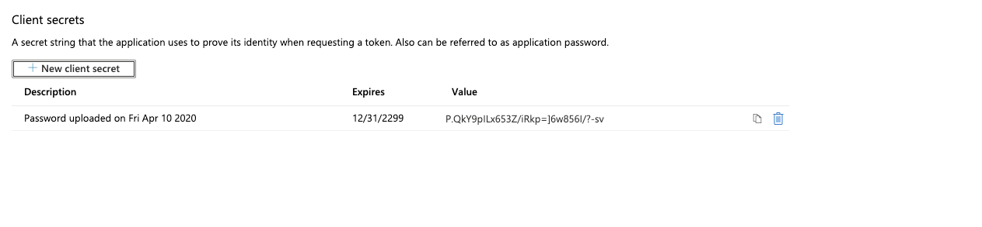

#### Step 5> Click a Resource Group >> create Key Vault

*This will be used to classify the Key Vaults.*

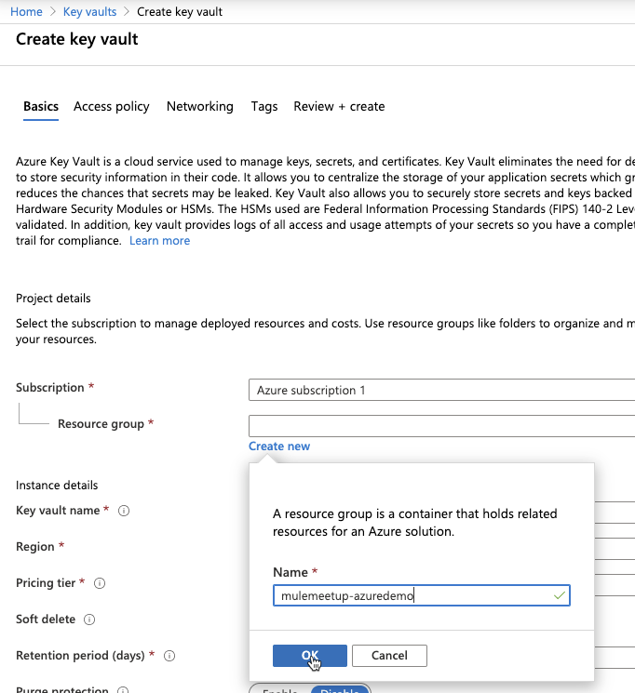

Key Vault Name creation

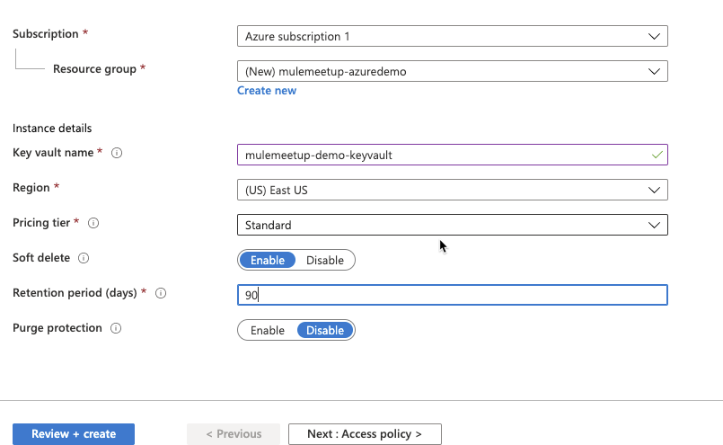

Review and Create >> Create

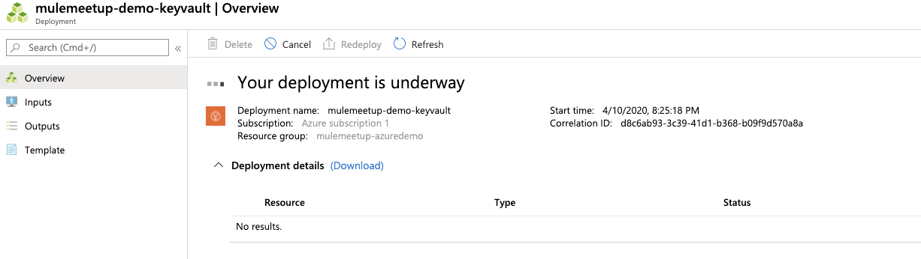

#### Step 6> Copy the vault Name and Vault URL

DNS Name: <https://mulemeetup-demo-keyvault.vault.azure.net/>

Vault Name: mulemeetup-demo-keyvault (**All lower case**)

#### Step 7> Provide access to the Application to the key Vault

This has to be done within Access policies from Key Vault >>> Add Access Policy

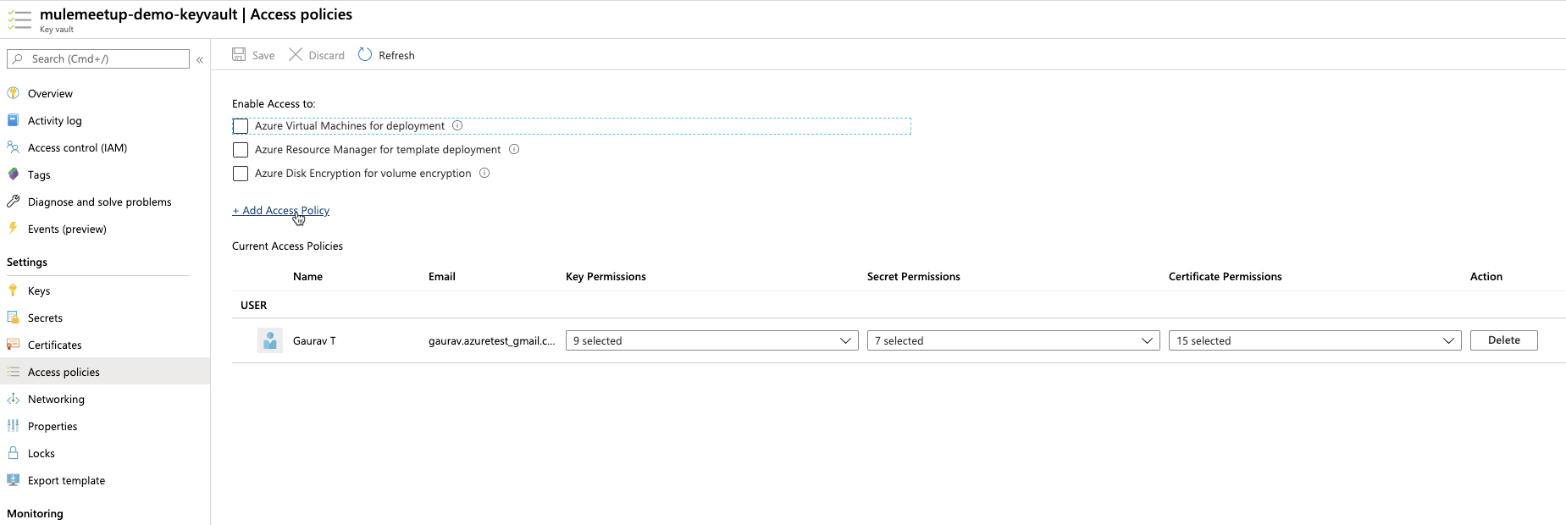

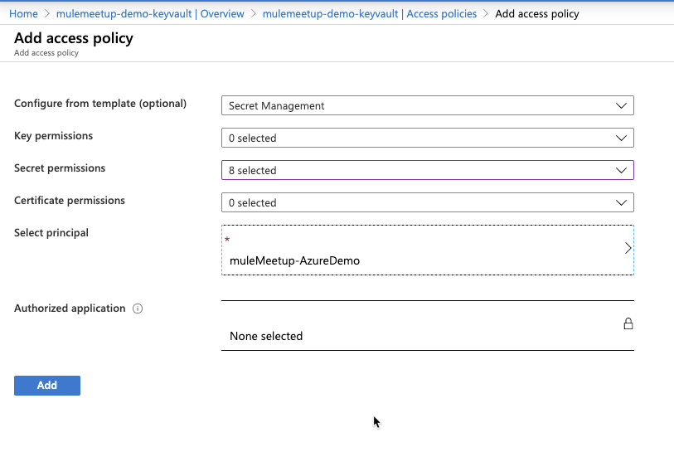

*Note: Note that Selecting Principal is mandatory and this is where you will select the Application which you created on previous steps*

**>>>> SAVE**

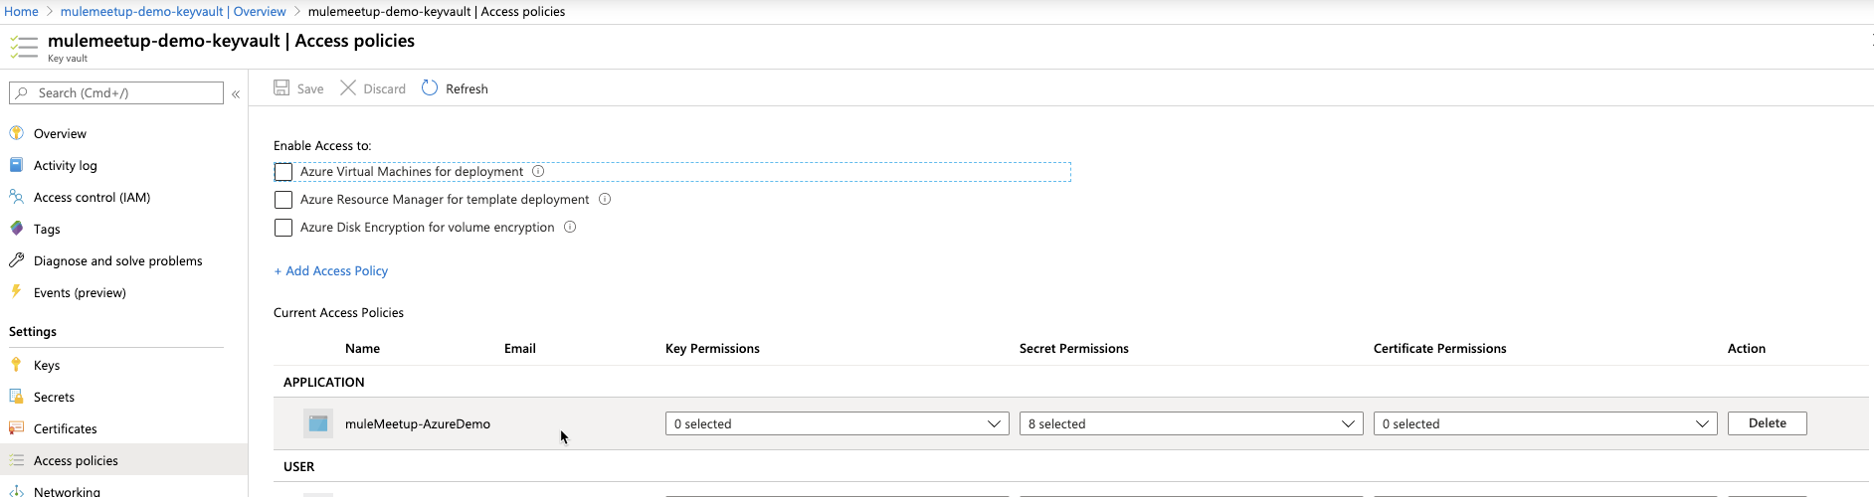

#### Step 8 >> Create a secret in Key Vault

Secrets are kept under “Secrets”

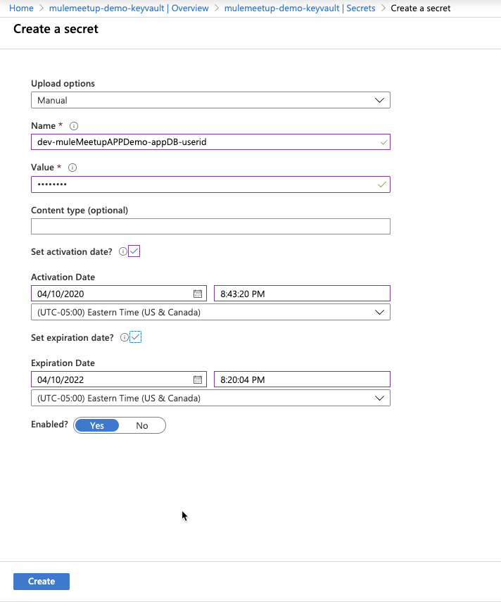

### POSTMAN testing of Key Vault API

#### Step 1> Setup environment variables (Better approach)

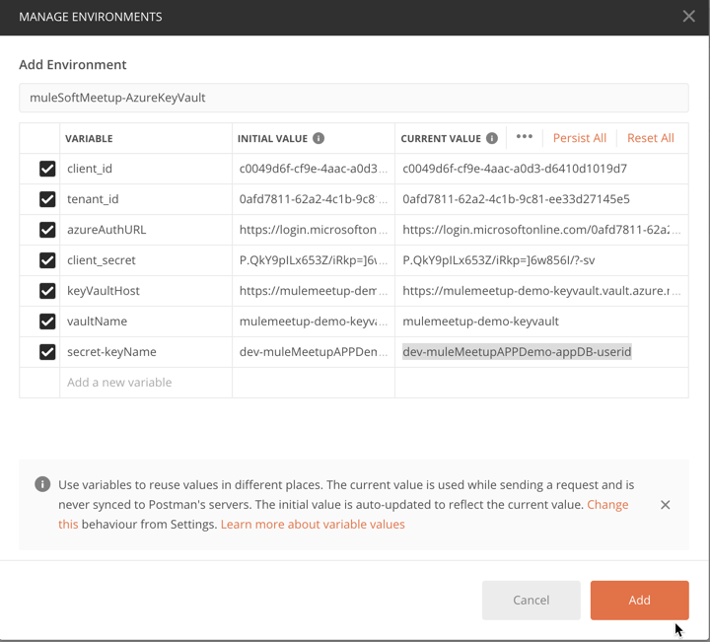

#### Step 2> Select the environment >> Configure Postman GET operation to hit Vault

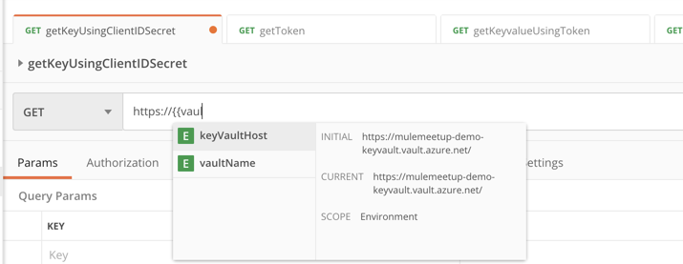

*Note:*

*Easy method to retrieve a single key : Copy the URL directly from Key Vault for the secret*

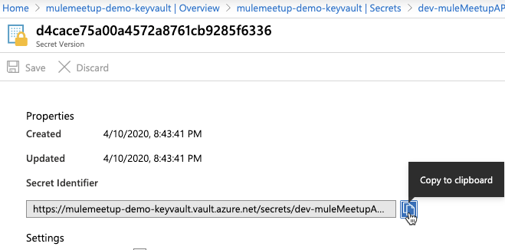

[*https://mulemeetup-demo-keyvault.vault.azure.net/secrets/dev-muleMeetupAPPDemo-appDB-userid/d4cace75a00a4572a8761cb9285f6336*](https://mulemeetup-demo-keyvault.vault.azure.net/secrets/dev-muleMeetupAPPDemo-appDB-userid/d4cace75a00a4572a8761cb9285f6336)

*If you want to always retrieve the latest version of the secret Value, use this instead*

[*https://mulemeetup-demo-keyvault.vault.azure.net/secrets/dev-muleMeetupAPPDemo-appDB-userid/?api-version=2016-10-01*](https://mulemeetup-demo-keyvault.vault.azure.net/secrets/dev-muleMeetupAPPDemo-appDB-userid/?api-version=2016-10-01)

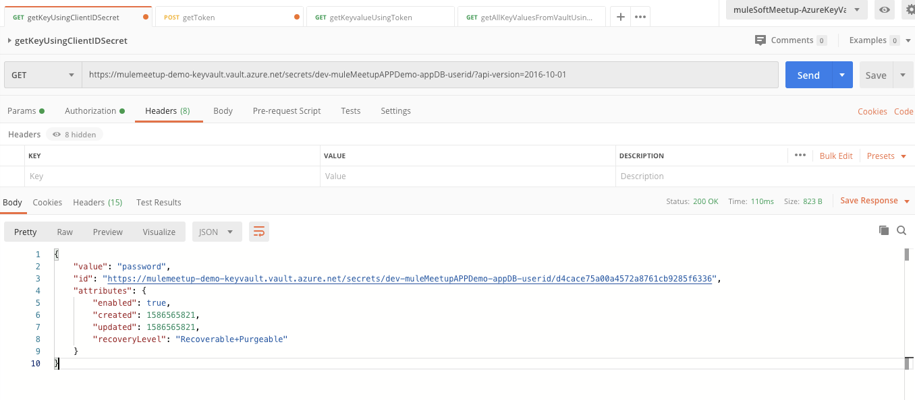

#### Step 3> Hit Azure Vault – With No Token

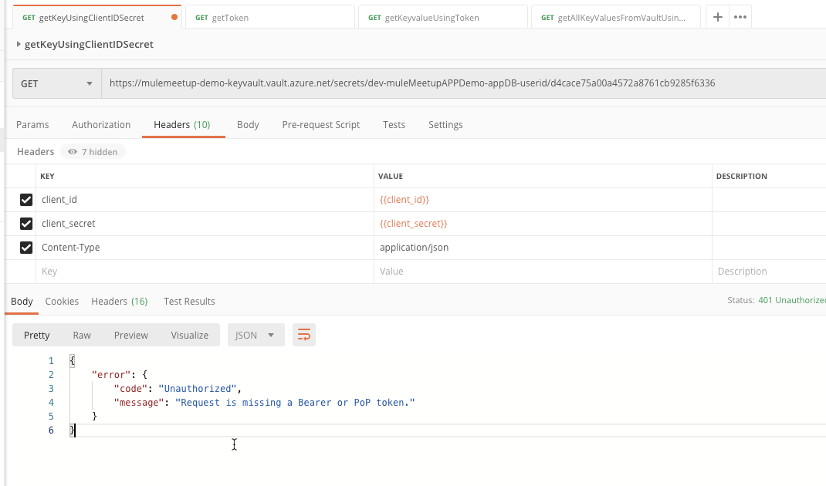

#### Step 4> Retrieval of Token

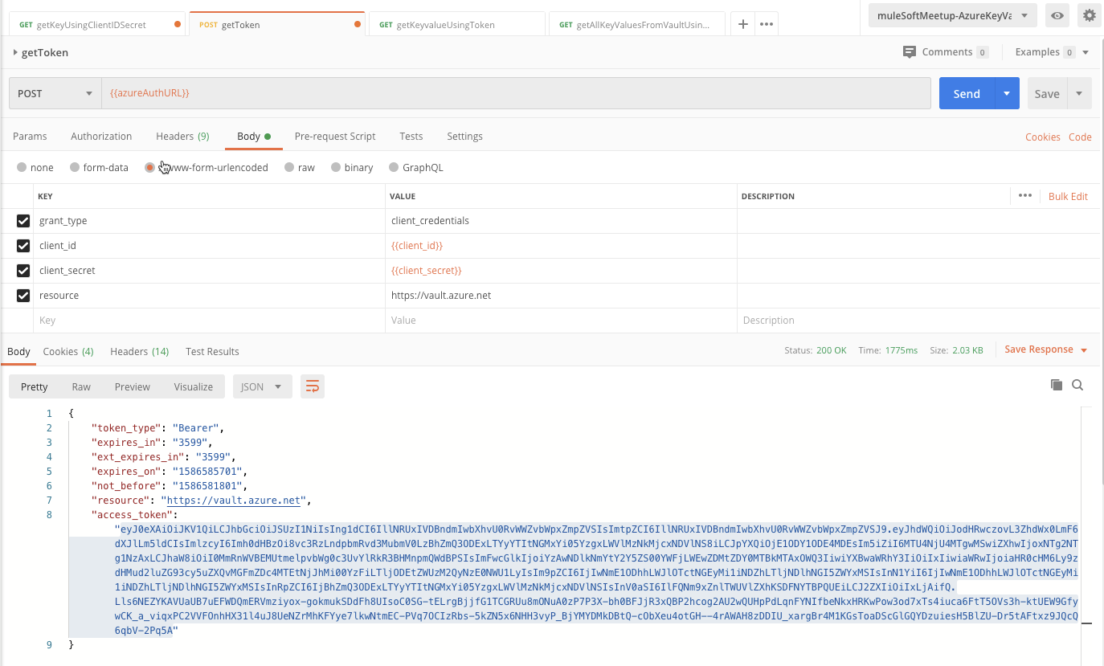

*Note: Below will be the error when the token is created without the Vault as the Resource Type*

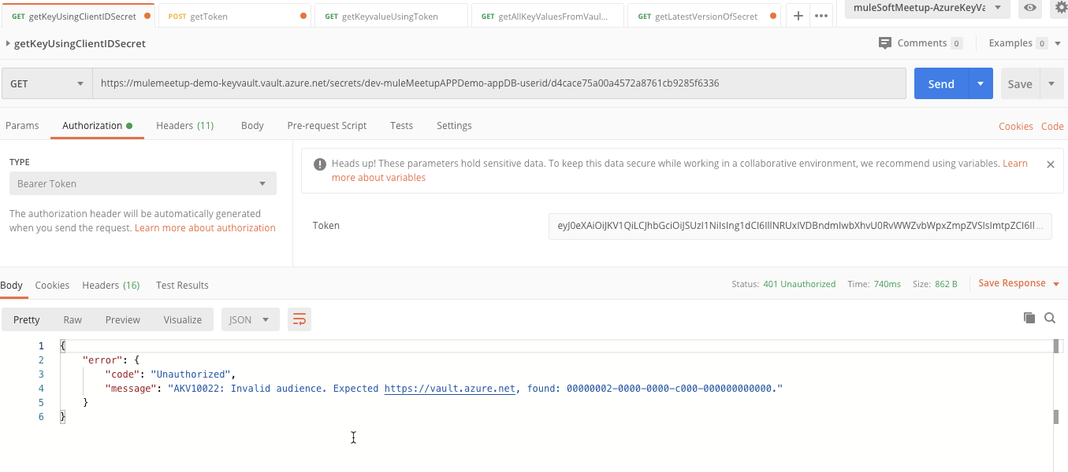

**Now the final step would be to copy the access_token and hit Azure Key Vault REST API successfully.**